CHAPTER 4: NETWORK LAYER: DATA PLANE

(a) For the network shown below with the given link costs, use Dijkstra’s algorithm to determine the shortest path from A to all other nodes

(b) Based on your answer to (a), what would the forwarding table at A look like?

(c) Consider the distance-vector routing algorithm applied to this network.

(d) Show the *initial* distance tables for nodes A, B, F and G (i.e. when each node is only aware of its immediate neighbours).

(ii) Show the distance table for node A after the first exchange of distance vectors between neighbours.

Q1) Consider the network shown in Figure 1. Answer the following questions: (a) Show the operation of Dijkstra’s (Link State) algorithm for computing the least cost path from F (the rightmost node in the figure below) to all destinations. List all the shortest path routes from F to all destinations that are the result of the algorithm’s computation.



(b) Show the distance table that would be computed by the distance vector algorithm in B. (Note: you do not have to run the distance vector algorithm; you should be able to compute the table by inspection.)



Q2. Consider the network shown in Figure 2 and assume that each node initially knows the costs to each of its neighbours. Consider the distance vector algorithm and show the distance table entries at node z.



Q3. Consider the count-to-infinity problem in the distance vector routing. Will this problem occur if we decrease the cost of a link? How about if we connect two nodes which do not have a link?

No, decreasing the cost of a link would not result in the count-to-infinity problem. Connecting two nodes is equivalent to decreasing the link weight from infinite to a finite value.

# Quiz (Week 8)

**Q1.** A Border Router is connected to more than one ISP. **True**or False?

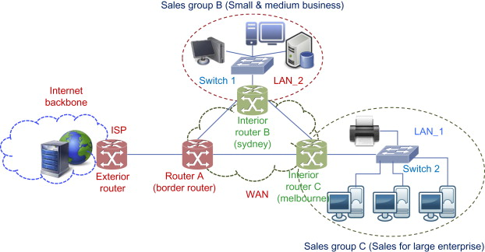

**Q2.** Each ISP must run intra-domain routing protocols to route packets within its domain. **True**or False?

**Q3.** In graph abstraction of communication networks, edges represent routers. True or **False?**

* Note represent routers
* Edge represents physical links between routers
* Value represents costs of forwarding packets from one router to another.

**Q4.** In graph representation of communication networks, all links must have identical costs/weights. True or **False?**

**Q5.** Shortest path represents the path with minimum number of hops:

**A. when all links have equal cost**

B. in any communication networks

C. when each hop has at least 1 ms of delay at minimum

D. when most hops are heavily loaded

**Q6.** In link state routing, routers must flood the network with any changes in its links. **True**or False?

**Q7.** Distance Vector scales better than Link State because it generally exchanges smaller size update packets with its neighbours. True or **False?**

**Q8.** With Distance Vector routing, each router must have the knowledge of the complete network topology. True or **False?**

**Q9.** For a network with 10 routers, the loop in Dijkstra's algorithm will be executed:

A. only once

**B.9 times**

C.10 times

D.11 times

**Q1** The only entries in a certain route table are (128.59.28.0/22, port 0), (128.59.28.0/23, port 1) and (128.59.28.0/24, port 2). These entries indicate CIDR network number, the prefix and the corresponding port to which a packet should be forwarded. If a packet arrives with a destination IP address equal to 128.59.29.18, which port will this router forward the packet to?

Answer: The address of the IP packet matches 128.59.28.0 in the first 23 bits. The 24th bit is different. Since we use the longest prefix match, the router will use the port corresponding to 128.59.28.0/23 in its route table and forward the packet to port 1.

**Q2**. A Router R1 has received a datagram with destination IP = 199.20.30.30.

The current routing table at R1 has got four entries as follows:

* 199.20.30.0/28 Interface 1
* 199.20.30.16/29 Interface 2
* 199.20.30.24/30 Interface 3
* Default Interface 4

Which interface would be selected by R1 to forward this packet? Show your working.

Answer: Network ranges 199.20.30.0/28 to 199.20.30.15/28 199.20.30.16/29 to 199.20.30.23/29 199.20.30.24/30 to 199.20.30.27/30 R1 would forward to interface 4.

**Q3**. Suppose an ISP owns the block of addresses of the form 101.101.128/17. Suppose it wants to create four subnets from this block, with each block having the same number of IP addresses. What are the prefixes (of form a.b.c.d/x) for the four subnets?

* 101.101.128/19
* 101.101.160/19
* 101.101.192/19
* 101.101.224/19

**Q4**. Suppose a peer with username Arnold discovers through querying that a peer with user name Bernard has a file it wants to download. Also suppose that Bernard is behind a NAT whereas Arnold isn’t. Let 138.76.29.7 be the WAN-side address of the NAT and let 10.0.0.1 be the internal IP address for Bernard. Assume that the NAT is not specifically configured for the P2P application.

(a) Discuss why Arnold’s peer cannot initiate a TCP connection to Bernard’s peer, even if Arnold knows the WAN-side address of the NAT, 138.76.29.7.